Integration Deployment

Guide

Avalara AvaTax Connector

Rest API v.2 for HCL Commerce v9

v1.0

This document is for informational purposes only. The information contained herein is subject to change without notice and is not warranted to be error-free. HCL Commerce and Avalara make no warranties, express, implied, or statutory, as to the information in this document.

This software is protected by intellectual property laws. Except as expressly provided in any written license agreement from HCL Commerce or Avalara, the furnishing of this document does not give you any license to HCL Commerce or Avalara’s patents, trademarks, copyrights, or other intellectual property and you may not use, copy, reproduce, translate, broadcast, modify, license, transmit, distribute, exhibit, perform, publish, or display any part, in any form, or by any means. Reverse engineering, disassembly, or decompilation of this software, unless required by law for interoperability, is prohibited.

**Trademark Notice**

Avalara, AvaTax Calc, AvaTax Returns, AvaTax Certs, AvaRates, TrustFile, BPObridge, Laserbridge+, Sales Taxll, Sales TaxPC, SalestaxPC+, StatetaxII, and StatetaxPC are either registered trademarks or trademarks of Avalara, Inc. in the United States, or other countries.

HCL Commerce is a registered trademark in the United States or other countries. All other trademarks are property of their respective owners.

**Third Party Content, Products, and Services Disclaimer**

This software and documentation may provide access to or information on content, products, and services from third parties. HCL Commerce and Avalara are not responsible for and expressly disclaim all warranties of any kind with respect to third-party content, products, and services. HCL Commerce and Avalara will not be responsible for any loss, costs, or damages incurred due to your access to or use of third-party content, products, or services.

**Disclaimer**

THIS SOFTWARE IS PROVIDED BY HCL COMMERCE ‘‘AS IS'' AND ANY EXPRESS OR IMPLIED WARRANTIES, INCLUDING, BUT NOT LIMITED TO, THE IMPLIED WARRANTIES OF MERCHANTABILITY AND FITNESS FOR A PARTICULAR PURPOSE ARE DISCLAIMED. IN NO EVENT SHALL HCL COMMERCE BE LIABLE FOR ANY DIRECT, INDIRECT, INCIDENTAL, SPECIAL, EXEMPLARY, OR CONSEQUENTIAL DAMAGES (INCLUDING, BUT NOT

LIMITED TO, PROCUREMENT OF SUBSTITUTE GOODS OR SERVICES; LOSS OF USE, DATA, OR PROFITS; OR BUSINESS INTERRUPTION) HOWEVER CAUSED AND ON ANY THEORY OF LIABILITY, WHETHER IN CONTRACT, STRICT LIABILITY, OR TORT (INCLUDING NEGLIGENCE OR OTHERWISE) ARISING IN ANY WAY OUT OF THE USE OF THIS SOFTWARE, EVEN IF ADVISED OF THE POSSIBILITY OF SUCH DAMAGE.

Contents

Introduction 4

Files included in the package 4

File Definitions 5

1. Dataload 5

2. LOBTools 6

3. Stores Project 6

4. WC 7

5. WebspehereCommerceServerLogic 7

Logging 7

Integration Instructions 8

Property Descriptions 9

Final Integration Testing 14

# Introduction

The Avalara Deployment Instruction Guide documents the options and processes involved in deploying the Avalara Tax plugin code to a WebSphere Commerce Version 9 website. Although built for the Aurora starter store, this integration can be easily integrated with any WebSphere Commerce V9 store implementation. The Avalara Deployment Instruction Guide is a resource to set up the tax calculation and address verification logic and flows along with their respective supporting assets. Review this Avalara Deployment Instruction Guide in its entirety prior to implementation. Follow the instructions within this guide to successfully deploy the Avalara Tax plugin. HCL Commerce is available to support your implementation if required. Please contact us at “HCL Sales Representative” if you require or desire implementation support or services*. With v9.1.11.0 we have added option to enter customer VAT id, it can be used for invoice purposes.

**IMPORTANT:** In this guide we assume that we have not customized HCS 9

## Files included in the package

The Avalara Deployment package includes the following artifacts:

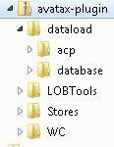

* dataload - access policy files and DB scripts
* LOBTools - customizations for LOBTools project of HCS
* Stores - customizations for Stores project of HCS
* WC - customizations for WC project of HCS

# File Definitions

## 1. Dataload

Contains access policy files and DB scripts.

1. **AvalaraACPolicy.xml**

The file contains the Access control policy required for **ACAvalaraAddressVerificationCmd, ACAvaTaxSettingsCmd,** and **ACAvalaraTestConnectionCmd** commands which are used for address verification and connection verification. This should be run on the server before the code is deployed.

1. **db.sql**

This file contains all the SQL changes that need to be completed to configure the Avalara Tax plugin. This should be run on the server before the code is deployed on a WebSphere Commerce server or test environment. Users need to replace the store ID value as required.

1. **custom tables in db.sql**

Additional tables are created in the database for Avatax integration usage:

* X_AVATAX_CONF - each row in the table contains avatax configuration per specific store
* X_AVATAX_USERS - each row in the table contains customer’s VAT ID associated with user’s address. These values are set at storefront during creating addresses by a customer.
* X_AVATAX_MBRGRP - each row in the table contains tax code associated with specific customer group. These values are configured in Management Center while configuring customer segments.
* X_AVATAX_DTL - tax details
* X_AVATAX_SHPMDDTL - additional parameters for shipping modes

**d. Prices include taxes logic**

SQL file contains four insert SQL commands for the next interfaces:

* com.ibm.commerce.order.commands.GetOrderTotalAmountCmd
* com.ibm.commerce.order.commands.GetHistoryOrderTotalAmountCmd
* com.ibm.commerce.order.commands.GetOrderReleaseTotalAmountCmd
* com.ibm.commerce.orderitems.commands.GetOrderItemsTotalAmountCmd

Inserting of this logic changes order calculation logic on Checkout depending on **‘Price include taxes’** setting in Avatax tab in Management Center. If prices include taxes and taxes shouldn’t be added to order subtotal - you have to check **‘Price include taxes’** checkbox. In this case taxes will not be added to Order Subtotal value.

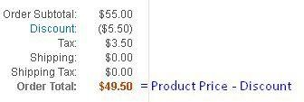

If you price doesn’t include taxes you have to leave this checkbox unchecked. In such case Taxes will be added to Order Subtotal.

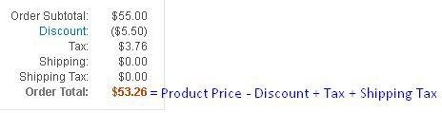

***Important: If you already have custom logic for calculating Order total, avoid inserting above four commands.***

## 2. LOBTools

This project contains files that are updated to implement UI changes for Avalara of HCS Management

Center. If you have your customizations, you could merge code into your version of files

## 3. Stores Project

This project contains files that are updated to implement UI changes for Avalara. The project includes **properties file, storetext properties, JSPs,Javascript, and css files**. To configure all these changes, you can directly merge the code into your version of these same **files, or add them to the appropriate version of these files to the extent you are using files with different names. struts-config-avalara.xml** - This file contains action-forward mapping that is created for Avalara commands and views. All the entries are store specific. We have shared the information as per our store configuration. If your store ID differs from these values, then the entries should first be updated with the correct store ID.

Please pay attention that **web.xml** should be merged with existent one

To merge JSPs please search for **<!-- Avalara code Begins -->** comment in a given **jsp** which marks the beginning of Avalara code and **<!-- Avalara code Ends -->** which marks the end. Merge the code present between these two comments into your corresponding jsps.

**JSP Code Details:**

NOTE: If your implementation uses different JSPs for User Registration and Checkout flows, you will need to incorporate the changes described above into your JSPs where appropriate. HCL Commerce can help with this integration if desired.

**JS Code Details:**

We need an independent Address Verification component for displaying the verified address on the screen.

The component will be defined at /components/address-validator/AddressValidator.tsx We have implemented this component on the checkout and the address book flow.

The changed for the same would be in the below files.

/components/checkout/address/Address.tsx

Used as

{showDialog?<AddressValidator addressData={addressFormData} updateAddress={updateAddressFormData} />:null}

The same can be implemented on below files.

components/pages/address-book/AddAddress.tsx components/pages/address-book/EditAddress.tsx

To merge JS please search for **<!-- Avalara code Begins -->** comment in a given **js files** which marks the beginning of Avalara code and **<!-- Avalara code Ends -->** which marks the end. Merge the code present between these two comments into your corresponding tsx files.

The service to call the address validator will be at the below file. /apis/address.service.ts

The Stores project also contains new property file **avatax.properties**. This file controls Avalara feature configuration.

## 4. WC

This directory contains necessary jar and configuration files. Directories could be merged with existent. If you have your own config customizations - merge avatax changes with yours.

## 5. WebspehereCommerceServerLogic

The directory contains new rest handler and commands for Avatax integration.

# Logging

Avalara tax integration logs requests/responses to a separate file (avalara.log by default) depending on settings in Management Center. The log file is named *avalara.log* and by default is located within the following directory:

**C:\WCDE_V9\wasprofile\logs\server1 or**

**./logs/server1**

Folder for placing log file is defined in com\ac\tax\avalara\avatax.properties file inside Stores project in the properties LOG_DIRECTORY, LOG_FILENAME.

We do not recommend making any changes to the file name or location, as this will make troubleshooting more difficult and require other code changes.

# Integration Instructions

### Step 1: Database modifications

Apply SQLs available in the **db.sql** file to toolkit and server databases as prior to or as part of your deployment procedure.

**Step 2: Copy WC changes**

Copy everything from WC directory of deployment package into WC project.

### Step 3: Copy WebsphereCommerceServerLogic

Copy everything from WebsphereCommerceServerLogic directory of deployment package into WebsphereCommerceServerLogic project.

Copy/ create the package structure to commands and handler package in project and copy the files

### Step 4: Copy Stores

Copy everything from Stores directory of deployment package into Stores project.

All other files contain code snippets which have to be injected to your corresponding files. Avalara code snippets start with <%-- BEGIN Avalara code --%> and end with <%-- END Avalara code --%> text.

When merging to Emerald follow the instructions under “JS Code Details” in the document.

### Step 5: Copy LOBTools

Copy everything from LOBTools directory of deployment package into LOBTools project.

All other files contain code snippets which have to be injected to your corresponding files. Avalara code snippets start with <%-- BEGIN Avalara code --%> and end with <%-- END Avalara code --%> text.

### Step 6: ACP Load

Run the **ACPLoad** against the **AvalaraACPolicy.xml** file present as a part of package. You can use the following deploy command to execute the **ACPLoad** command for Avalara resources.

C:\WCDE_V9\bin>acpload.bat C:\WCDE_V9\xml\policies\xml\AvalaraACPolicy.xml

Please enter the password when prompted.

You may choose to add the contents of this access control xml file to your own ACPLoad script used during deployment procedures.

### Step 7: Create and configure Avalara properties

Create the package **src\com\ac\tax\avalara\** within the Stores project and place **avatax.properties** into that package. Note that the workspace folder location is usually **workspace\Stores\ src\com\ac\tax\avalara\**.

This file contains default settings for Avatax integration and messages which are appeared to customer on pop-up dialog. Some settings from the file are used in case avatax is not configured to the specific store in Management Center.

A summary and explanation of each property you can configure is included below. *Important: There are several properties in the* ***avatax.properties*** *file that should not be changed. These properties are below a comment line asking you not to edit the properties.*

Depending on how properties files are managed in your application, a server restart, registry refresh or an alternate method may be required for your application to pick up properties file value changes.

# Property Descriptions:

**NOTE – The boolean values below must be set to ‘true’ or ‘false’, and the syntax for properties file entries is KEY = VALUE. Where we show a property key’s value as text inside open/close brackets like: account = “<your account number>”, you will replace the entire value with the your value as in: “account = 12345”**

|  |  |  |  |  |  |  |  |  |  |  |  |  |  |  |  |  |  |  |  |  |  |  |  |  |  |  |  |  |  |  |  |  |  |
| --- | --- | --- | --- | --- | --- | --- | --- | --- | --- | --- | --- | --- | --- | --- | --- | --- | --- | --- | --- | --- | --- | --- | --- | --- | --- | --- | --- | --- | --- | --- | --- | --- | --- |
|  | **avatax.properties** | | |  | | | | | | | | | |  | | | | | | | | | | | | | | | | | | | |
|  | | **Property File Entry** | | | | |  | | | | | | |  | | | | | | **Purpose / Explanation** | | |  | | | | | | | | | | |
| URL=https://sandbox-rest.avatax.com | | | | | | | | | | | | | |  | Default base URL of Avatax web service | | | | | |  | | | | | | | | | | | | |
|  | | | | | |
| URLS=https://sandbox-rest.avatax.co m|https://rest.avatax.com | | | | | | | | | | | | | |  | List of base Avatax webservice URLs separated by | character. These values are | | | | | | | | | | | | | | | |  | | |
| shown in Management Center in ‘Url to connect’ field. | | | | | | | | | | | | | | | |
|  | ACCOUNT = <Your avatax account> | | | | | | | | |  | | |  |  | Specify your account value in the property if you would like to enable Avatax | | | | | | | | | | | | | | ment | | | | |
|  | | | | | | | | | integration for some Store even if Avatax access is not configured in Manage Center for it. This value provided by Avalara. | | | | | | | | | | | | | |
| AUTH_KEY = <Your avatax auth key> | | | | | | | | | | | | |  |  | Specify your authentication key in the property if you would like to enable Avatax | | | | | | | | | | | | | | | | | | t |
| integration for some Store even if Avatax access is not configured in Managemen Center for it. This value provided by Avalara. | | | | | | | | | | | | | | | | | |
|  | COMPANY_CODE = <Your company code> | | | | | | | | | | |  |  |  | Specify your company code in the property if you would like to enable Avatax | | | | | | | | | | | | | | | ment | | | |
|  | | | | | | | | | | | integration for some Store even if Avatax access is not configured in Manage Center for it. This value provided by Avalara. | | | | | | | | | | | | | | |
| TIMEOUT_REQUEST=10000 | | | | | | | | | | | | |  |  | Time out of a request to Avatax web service. | | | | | | |  | | | | | | | | | | | |
|  | | | | | | |
|  | HEADER_USER_AGENT=AvaTax16 agent | | | | | | | | | |  | |  |  | Header value field which is used while sending requests to Avatax. | | | | | | | | | | | | |  | | | | | |
|  | | | | | | | | | |  | | | | | | | | | | | | |
| ADDRESS_VALIDATION_URL=address/acco unt/%s/company/%s/resolve | | | | | | | | | | | | |  |  | URL for address validation which is added to the Avatax base URL | | | | | | | | | | | |  | | | | | | |
|  | | | | | | | | | | | |
| CALCULATION_URL=calculations | | | | | | | | | | | | |  |  | URL for taxes calculation which is added to the Avatax base URL | | | | | | | | | | |  | | | | | | | |
|  | | | | | | | | | | |
| RECORD_URL=transactions | | | | | | | | | | | | |  |  | URL for recording taxes which is added to the Avatax base URL | | | | | | | | | | |  | | | | | | | |
|  | | | | | | | | | | |
| STATE_TRANSITIONS_URL=transactions/ account/%s/company/%s/Sale/%s/state  Transitions | | | | | | | | | | | | |  |  | URL for changing state of transaction taxes which is added to the Avatax base URL | | | | | | | | | | | | | | | | | |  |
|  | | | | | | | | | | | | | | | | | |
| ZIP_CODE_PATTERN_US,  ZIP_CODE_PATTERN_CA,  ZIP_CODE_PATTERN_GB,  ZIP_CODE_PATTERN_NL | | | | | | | | | | | | |  |  | Regular expressions to validate zip codes for corresponding country (US - United | | | | | | | | | | | | | | | | |  | |
| States, CA - Canada, GB - United Kingdom, NL - Netherlands).  You can freely add additional zip code expression by naming property ZIP_CODE_PATTERN_ and add country code. | | | | | | | | | | | | | | | | |
| PING_ADDRESS1, PING_COUNTRY,  PING_STATE, PING_CITY,  PING_ZIP_CODE | | | | | | | | | | | | |  |  | Default address values which are used to send validate address request when us | | | | | | | | | | | | | | | | | | er |
| clicks ‘Test’ button in Management Center to verify correctness of Avatax settings. | | | | | | | | | | | | | | | | | |
|  | LOG_DIRECTORY, LOG_FILENAME, | | | | | | |  | | | | |  |  | Logger settings. Settings to specify directory, file name and period to save logs for | | | | | | | | | | | | | | | | | |  |
| LOG_KEEP_HOURS | | | | | | | requests/responses to/from Avatax. | | | | | | | | | | | | | | | | | |
|  | | | | | | | | | | | | |  |  | | | | | | | | | | | | | | | | | | | |
|  | MULTIPLE_FULFILLMENT_CENTER = 1 | | | | | | | | |  | | |  |  | If MULTIPLE_FULFILLMENT_CENTER Flag =1, then look to | | | | | | | | | | | | | | | | |  | |
|  | | | | | | | | | STADDRESS table for FFMCENTER address,If Flag=0, then | | | | | | | | | | | | | | | | | |  |
| take default address from config file. | | | | | | | | |  | | | | | | | | |
|  | #Default Store Address incase | | | | | | | |  | | | |  | Comment field | | | | | | | | | | | | | | | | | | | |
| MULTIPLE_FULFILLMENT_CENTER flag is | | | | | | | | | | | |
| set to 0. | | | | | | | | | | | | |  |  | | | | | | | | | | | | | | | | | | | |
|  | DEFAULT_ADDRESS_LINE1 = <address1> | | | | | | | | | | |  |  | Address line 1 | | |  | | | | | | | | | | | | | | | |
|  | DEFAULT_ADDRESS_LINE2 = <address2> | | | | | | | | | | |  |  |  | Address line 2 | | |  | | | | | | | | | | | | | | | |
|  | DEFAULT_ADDRESS_CITY = <City> | | | | | | | |  | | | |  |  | City |  | | | | | | | | | | | | | | | | | |
|  | DEFAULT_ADDRESS_STATE = <state> | | | | | | | | |  | | |  |  | State (USE TWO DIGIT STATE ABBREVIATION) | | | | | | | | | |  | | | | | | | | |
|  | DEFAULT_ADDRESS_COUNTRY = | | | |  | | | | | | | |  | Country (USE COUNTRY CODE e.g. ‘US’, ‘CA’) | | | | | | | | | | | | | | | | | | | |
| <CountryCode> | |  | |
|  | DEFAULT_ADDRESS_ZIP_CODE = | | | | |  | | | | | | |  |  | Zip / Postal Code | | | |  | | | | | | | | | | | | | | |
| <zipcode> |  | | | |  | | | |
| #API configuration Parameters | | | | | | | | | | | | |  | Comment field | | | | | | | | | | | | | | | | | | | |
|  | VAT_ID_LABEL = BIN# /VAT ID | | | | | |  | | | | | |  |  | Name of the field for VAT ID which is displayed on | | | | | | | | | | | | | |  | | | | |
|  | | | | | | Storefront. | |  | | | | | | | | | | | |

|  |  |  |  |  |  |  |  |  |  |  |  |  |  |  |  |  |  |  |  |  |  |  |  |  |  |  |  |  |  |  |  |  |  |  |
| --- | --- | --- | --- | --- | --- | --- | --- | --- | --- | --- | --- | --- | --- | --- | --- | --- | --- | --- | --- | --- | --- | --- | --- | --- | --- | --- | --- | --- | --- | --- | --- | --- | --- | --- |
|  | | | | | | | | | | | |  |  | You may edit the text after the equal sign | | | | | | | | | | | | | |  | | | | | | |
|  | ADDRESS_VERIFICATION_SUBTITLE = | | | | | | | |  | | |  |  | Information message which is shown on Avalara Address | | | | | | | | | | | | | | | | | |  | | |
| There's a problem with the address | | | | | | | | | | | verification dialog. | | | | |  | | | | | | | | | | | | |
| provided - we've marked our | | | | |  | | | | | | You may edit the text after the equal sign but do not | | | | | | | | | | | | | | | | | |
| suggestions <span | |  | | | edit the text between the “<>” symbols. | | | | | | | | | | | | |  | | | | |
| class="addrerror"> in red </span> | | | | | | | | | |  |  | | | | | | | | | | | | |
| below. Please choose which version | | | | | | | | | | |
| of the address you want to use, or | | | | | | | | | | |
| click <b>Edit</b> next to the | | | | | |  | | | | |
| address you want to change. | | | | |  |
|  | SELECT_ADDRESS_TITLE = We Have | | | | | | |  | | | |  |  | Title of the Avalara address verification dialog. | | | | | | | | | | | | | | |  | | | | | |
| Validated Your Address | | | |  | | | You may edit the text after the equal sign | | | | | | | | | | | | | |  |
|  | ERROR_SAME_ADDRESS_NAME = The | | | | | |  | | | | |  |  | Text which is displayed on Avalara address verification | | | | | | | | | | | | | | | | | | | |  |
| Address Name you entered already | | | | | | | | |  | | dialog. | |  | | | | | | | | | | | | | | | | | |
| exists. Type a unique name in each | | | | | | | | | | | You may edit the text after the equal sign | | | | | | | | | | | | | |  | | | | | |
| Address Name field and try again. | | | | | | | | | |  |  | | | | | | | | | | | | | |
| DEFAULT_TAX_RATE = 5.00 | | | | | | | | | | | |  |  | Default tax rate is used in case BEHAVIOUR_ON_ERROR | | | | | | | | | | | | | | | |  | | | | |
| equals to SETDEFAULTTAX value. | | | | | | | | |  | | | | | | |
| This value from properties file is used if you imported | | | | | | | | | | | | | | | | | | | |  |
| Avatax plugin and have not configured it for specific | | | | | | | | | | | | | | | | | |  | |
| store in Management Center. | | | | | | | |  | | | | | | | | | |
|  | AVATAX_COMMIT_ON_ORDER_STATUS = M | | | | | | | | | |  |  |  | Order status when to commit taxes. | | | | | | | | | | |  | | | | | | | | | |
|  | | | | | | | | | | Value M corresponds to ‘Pending Payment authorization’ | | | | | | | | | | | | | | | | | | |  | |
| status. | |  | | | | | | | | | | | | | | | | |
| Full diagram of statuses is available here  https://help.hcltechsw.com/commerce/9.1.0/developer/refs | | | | | | | | | | | | | | | | | | | | /r |
|  | | | | | | | | | | | |  |  | osordstattran.html?hl=order%2Cstatus%2Ctransition%2Cflow | | | | | | | | | | | | | | | | | | | | %2 |
| Cdiagram | | | | | | | | | | | | | | | | | | | |
|  | TAX_INCLUDED=false | | |  | | | | | | | |  |  | Specifies whether Prices of products include taxes. It | | | | | | | | | | | | | | | | | | |  | |
|  | | | is used when Avatax has not configured for a store in | | | | | | | | | | | | | | | | | |  |
| Management Center. | | | |  | | | | | | | | | | | | | |
|  | VAT_ID_CONFIGURATION_ENABLED=false | | | | | | | | | |  |  |  | Specifies whether VAT ID field should be displayed on | | | | | | | | | | | | | | | | | |  | | |
|  | | | | | | | | | | storefront. | | |  | | | | | | | | | | | | | | |
|  | LOG_REQUEST_TYPE=PING,VALIDATE_ADDR | | | | | | | | | | |  |  | Specifies types of requests separated by comma which | | | | | | | | | | | | | | | | |  | | | |
| ESS,CALCULATE_TAXES,RECORD_TAXES,CA | | | | | | | | | | | have to be stored in the file. | | | | | | | | |  | | | | | | | |
| NCEL_TAXES |  | | | | | | | | | |  | | | | | | | | |
| BEHAVIOUR_ON_ERROR=SETDEFAULTTAX | | | | | | | | | | | |  |  | Behavior in case Avatax service doesn’t work. Possible | | | | | | | | | | | | | | | | | | |  | |
| values are: | | |  | | | | | | | | | | | | | | | |
| DONTALLOW - don’t allow to proceed with checkout, | | | | | | | | | | | | | | |  | | | |
| SETDEFAULTTAX - set default tax rate which is taken | | | | | | | | | | | | | | | |  | | |
| from DEFAULT_TAX_RATE property, | | | | | | | | | |  | | | | | |
|  | | | | | | | | | | | |  | ALLOWTAX0 - set 0 tax rate for the order. | | | | | | | | | | | | | | | | | | | | | |
|  | TAX_CALCULATION_MODE=ENABLE_WITH_TA | | | | | | | | | | |  | Tax calculation mode can have 3 different values: | | | | | | | | | | | | | | |  | | | | | |
| X | | | | | | | | | | | DISABLE - disable tax calculation. In this case Avata | | | | | | | | | | | | | | | | | |  | | |
| web service is not called. | | | | | | |  | | | | | | | | | | |
| ENABLE_WITHOUT_TAX - calculation of taxes is enabled | | | | | | | | | | | | | | | | |  |
| without submitting taxes. | | | | | |  | | | | | | | | | | |
| ENABLE_WITH_TAX - calculation and submission of taxes | | | | | | | | | | | | | | | | | |
| to Avatax is enabled | | | | |  | | | | | | | | | | | | |
| TAX_CODE_IDENTIFIER=TaxCode | | | | | | | | | | | |  |  | Name of the attribute which has Item code values. This | | | | | | | | | | | | | | | | | | |  | |
| attribute has to be applied to a product with specific | | | | | | | | | | | | | | | | | | |
| value. |  | | | | | | | | | | | | | | | | | |
|  | AVALARA_HTS_ATTRIBUTE_PREFIX=HTS_ | | | | | | | | |  | |  |  | Default prefix for HTS code attribute | | | | | | | | | | | |  | | | | | | | | |

Step 8: Configure SSL certificates

In order to facilitate communications between your servers and Avalara’s servers, SSL certificates must be installed on your WebSphere Commerce Application Servers. You may need to work with your IT department of implementation/managed services partner to execute these steps. NOTE, like with the test vs production URL, you will need to install a different SSL certificate on the production server.

Follow the instructions below to setup SSL certificates for Avalara (https://sandbox-rest.avatax.com) or (https://rest.avatax.com) for development and production certificates.

1. Open the IBM **Integrated Solutions Console** (right click in RAD on "WebSphere commerce server" -> Administration -> **Run administrative console**, or just open the appropriate url, usually found at: http://localhost:9060/ibm/console/login.do)

1. Open in admin console "**Security**" -> "**SSL certificate and key management**" ->"**Key stores and certificates**" -> "**NodeDefaultTrustStore**" -> "**Signer certificates**"

1. You should come to the page (already has imported certificate):

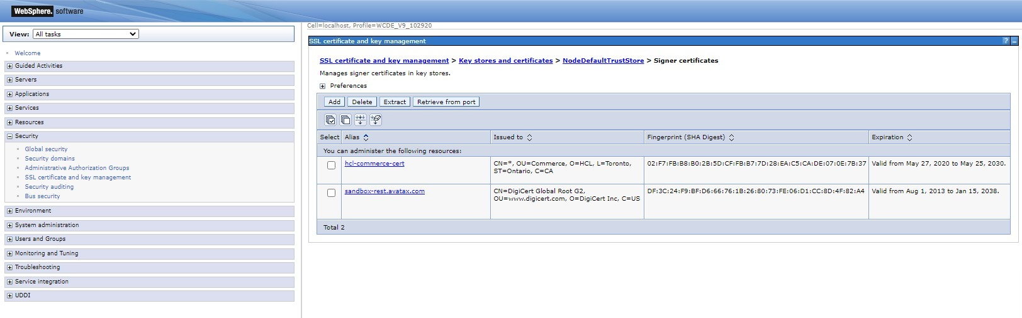

Click on "**Retrieve from port**" button

In host field put "**sandbox-rest.avatax.com**" or "**rest.avatax.com**" (depending on which environment you will use) in port field put "**443**" in alias filed put "**sandbox-rest.avatax.com**" or "**rest.avatax.com**".

Click on "**Retrieve signer information**" button

Click "**Ok**" button and then "**save**" link

Step 9: Setup ItemCode vs TaxCode

In order for the Avalara service to know what tax to apply to what item, a new descriptive attribute should be created in the attribute dictionary. Your product feed should include a method to create the attribute for each product and update its value to reflect the appropriate Avalara tax code for that product. NOTE: the attribute must first exist in the attribute dictionary (this attribute is only created ONCE in the dictionary). Feeds or manual updates for products involve you assigning the attribute and appropriate value to the product in question.

Name of the attribute must be specified in the Tax code identifier field in Management Center in Avatax tab.

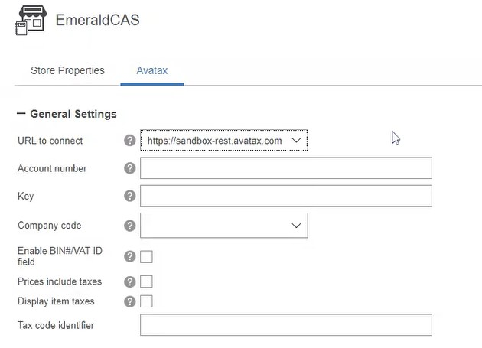

The list of valid codes can be gotten from the Avalara administrative console as part of your setup with Avalara. We don’t provide them in this guide because they are subject to change. Avalara will notify you from time to time if there are changes to codes that affect you, or additional codes available for use.

**The HCL help center fully describes how to create a new descriptive attribute in the attribute dictionary:**

[https://help.hcltechsw.com/commerce/9.1.0/management-](https://help.hcltechsw.com/commerce/9.1.0/management-center/tasks/tpnattdiccreate2.html?hl=creating%2Cattributes%2Cattribute%2Cdictionary)

[center/tasks/tpnattdiccreate2.html?hl=creating%2Cattributes%2Cattribute%2Cdictionary](https://help.hcltechsw.com/commerce/9.1.0/management-center/tasks/tpnattdiccreate2.html?hl=creating%2Cattributes%2Cattribute%2Cdictionary)

Once done with Configuration and code deployment you can test the integration by creating an order and checking your transaction details in the Avalara Administrative console.

### Step 10: Setup TAX codes for shipping modes

Insert into X_AVATAX_SHPMDDTL table appropriate data for each shipping mode you will be using. Fo

Landed Cost functionality you also need to specify mode [‘air’, ‘ground’, ‘ocean’] and is mode express

(‘Y’ or ‘N’). Also insert appropriate TAX code for your shipping method

# Final Integration Testing

Once your integration is complete configure Avatax settings in Management Center for your store - enable address validation and taxes recording in order to check the whole workflow.

1. After configuring Avatax settings check connection with Test Connection Button. Avalara test connection can be accessed in Management Center to verify your configuration. Status of your connection is displayed above the button.

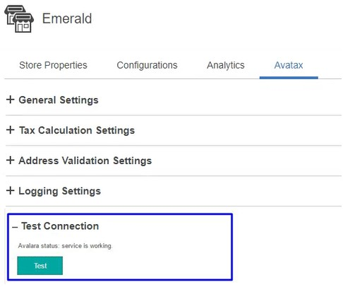

After that you should check Avalara logic on storefront and to see the following screens (or your equivalents) updated while browsing your site.

1. **Register** or **Profile Edit** page,

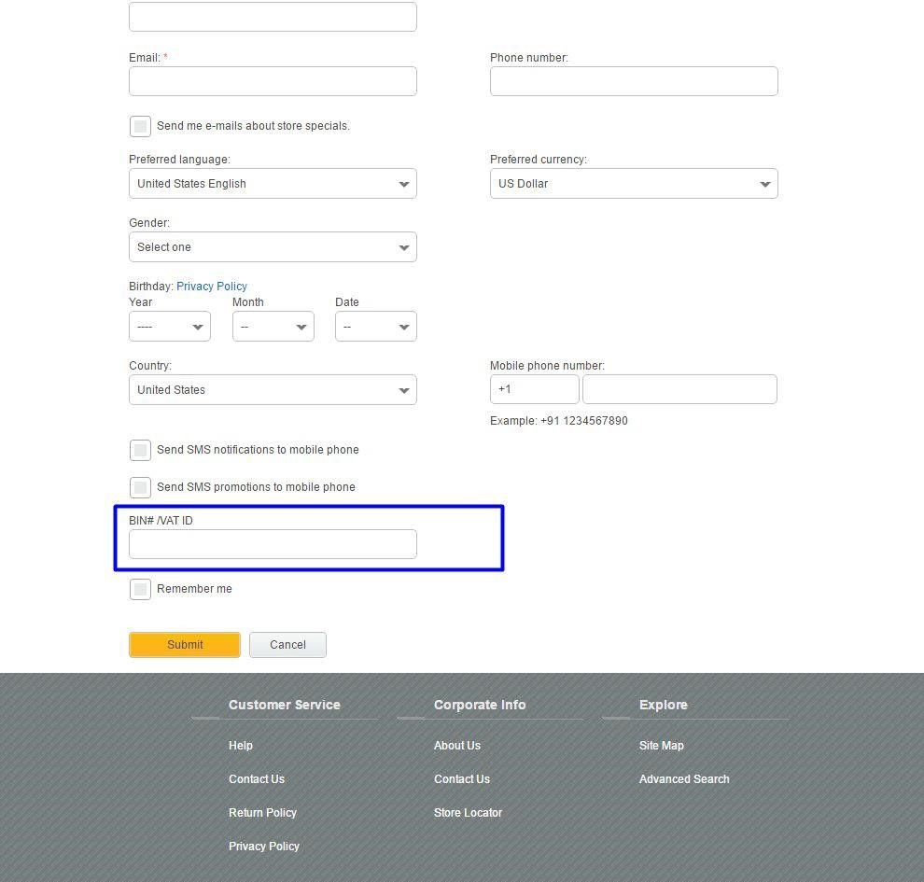

If you’ve checked ‘Enabled VAT ID field’ in Management Center, the **Register** page should have additional field at the bottom of the form where the user can specify a VAT/BIN number.

**NOTE: VAT ID is not supported in Emerald yet.**

1. If Address validation is enabled for Registration page in Management Center, then addresses entered during registration should trigger the address validation logic which asks the user to select the returned Avalara normalized address or to continue registration with the address as entered.

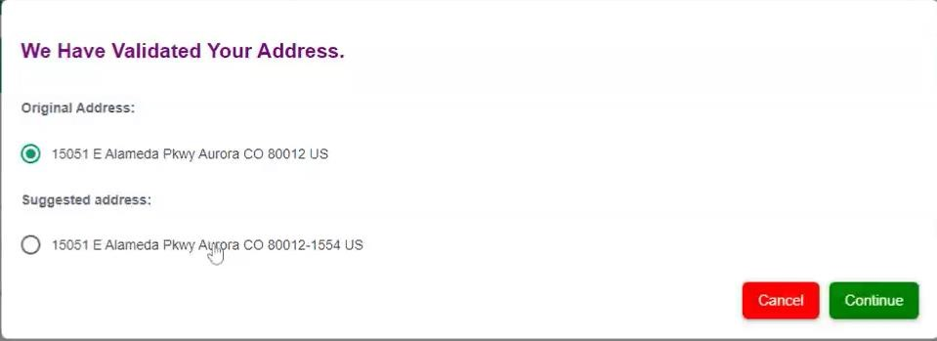

The above verification popup should appear (via ajax/REST API call) upon the user exiting the last address form field on the **Registration, Profile edit, Address book and Checkout** jsp pages so long as you have enabled address verification at Address Page in My Account, Quick Profile page in My Account, Checkout.

1. The **My Account, Address book** and **Checkout** pages are updated to include field for VAT/BIN # assuming these features have been enabled as per the item #1, above.

1. By default no tax or estimated tax is shown in the cart. If estimated tax in the shopping cart is important for your business, the logic can be customized to retrieve an estimated or default tax value depending on your business needs. This is not something that can be done without customizing the code. Tax is shown on the shipping and billing pages during checkout once appropriate address information has been provided.

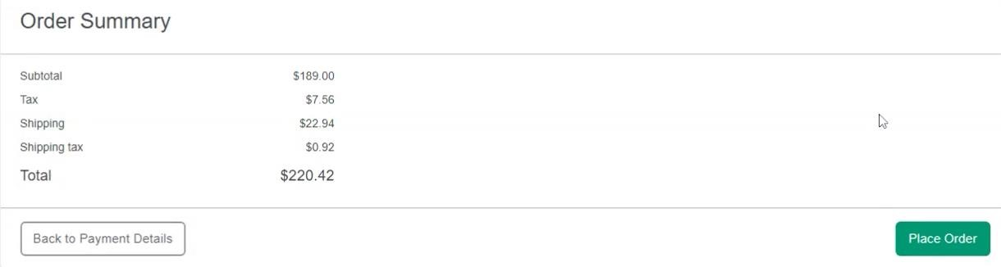

1. If you enabled taxes recording you can check record transaction in Avatax admin panel once order is complete.

Complete an order in your store.

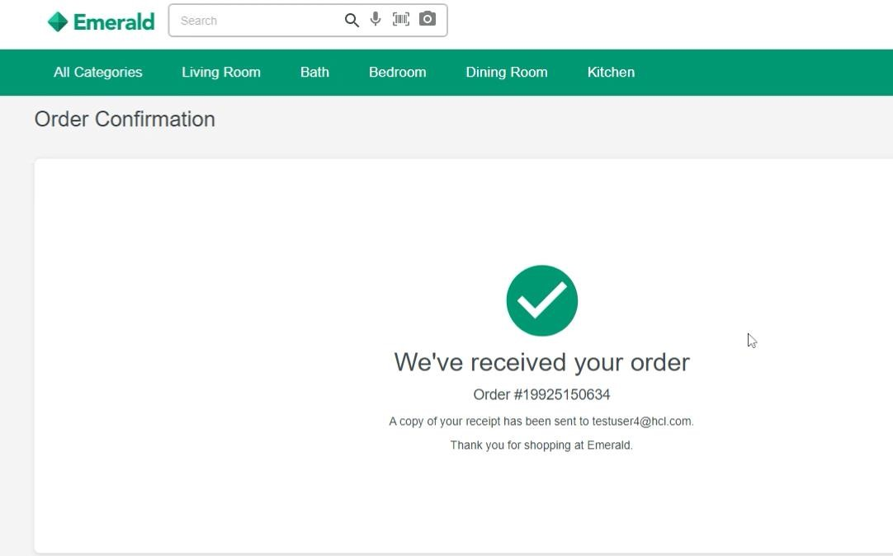

On completion of an order, you can login <https://sandbox.admin.avalara.com/>**(or)** depending on your environment check whether your transaction against an order is recorded properly with correct data.

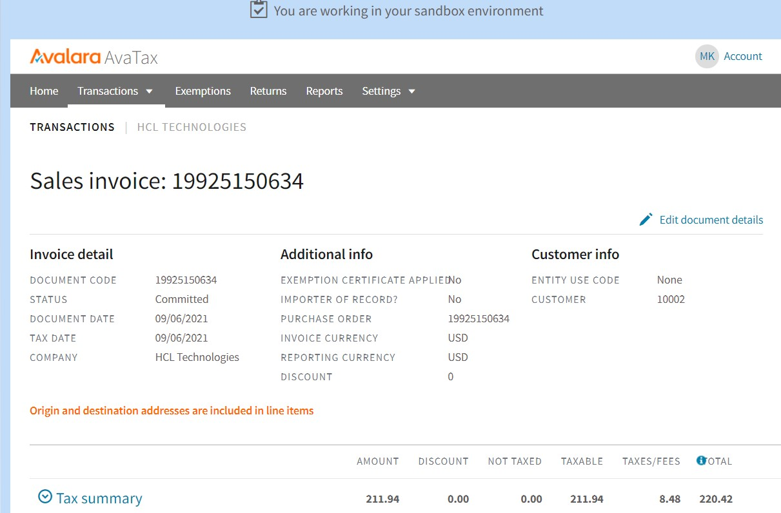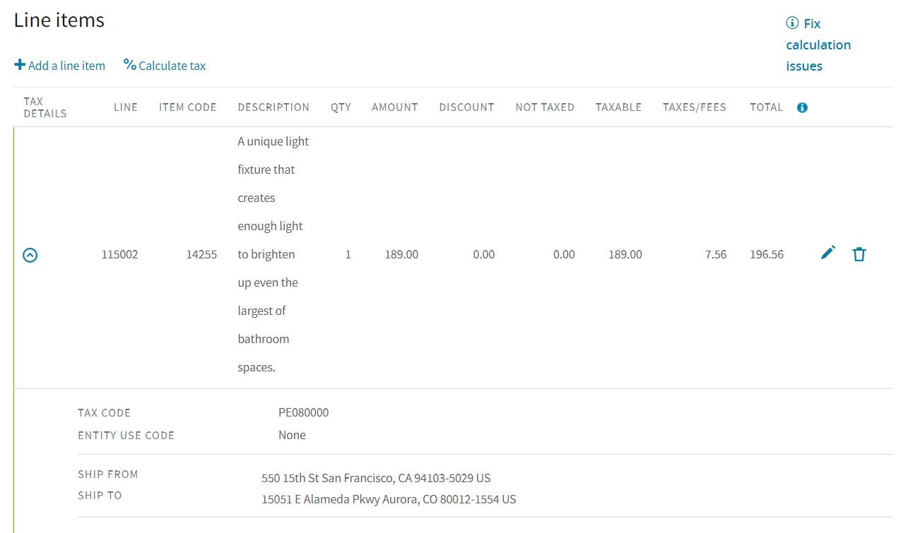

**Tax Breakdown:**

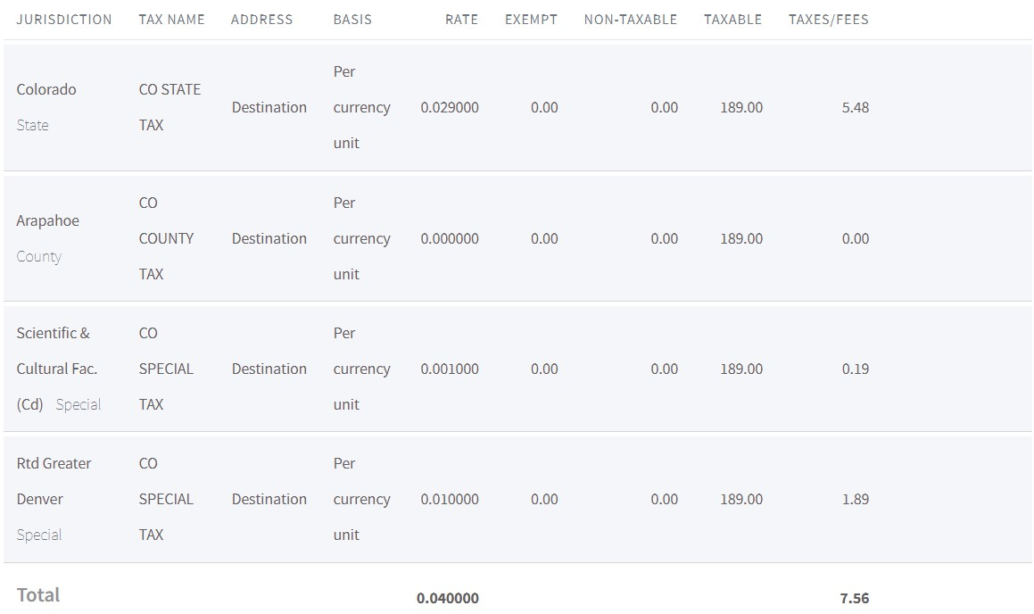

**Shipping Tax:**

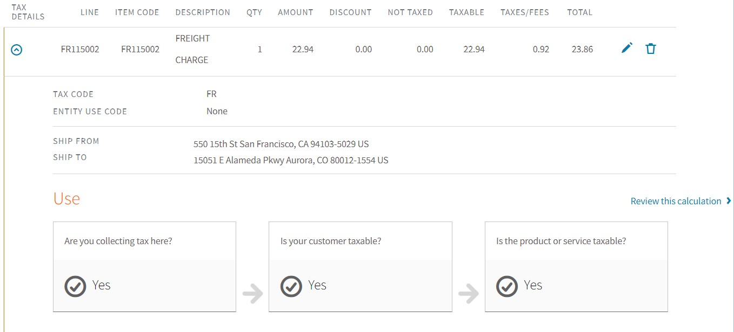

**Shipping Tax Breakdown:**

